Alexander Baldree
2/3/2026
Module 5.1 Discussion Board
CSD340

Topic #37 – People Screen Out Information That Doesn’t Fit Their Beliefs

This concept explains that people naturally filter out information that contradicts what they already believe. Instead of objectively evaluating all content, users tend to focus on messages that confirm their existing opinions and ignore or dismiss the rest. In web design, this means users may overlook important information if it conflicts with their expectations, values, or assumptions.

Embellishment:
What the reading doesn’t fully address is how this affects persuasive design and accessibility. If content challenges a user’s beliefs too directly, they may disengage entirely. Designers can reduce resistance by framing information in a neutral, respectful tone and using evidence-based visuals such as charts, testimonials, or real-world examples. For example, health or educational websites often present information gradually and use storytelling to help users feel understood rather than judged.

Visual Example:

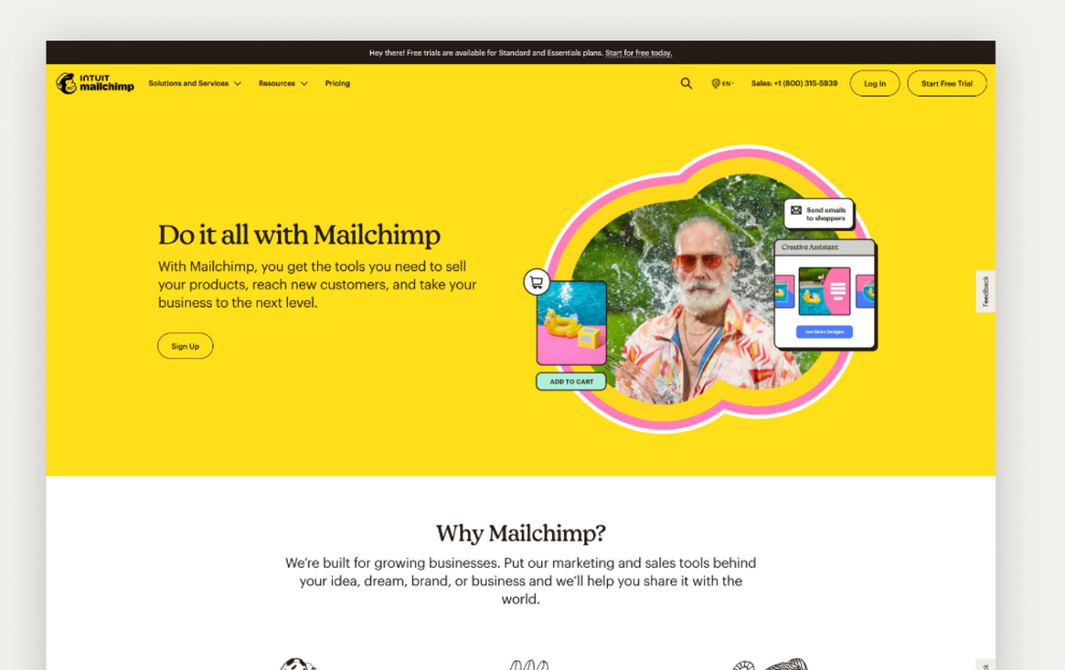
⸻

Topic #41 – People Habituate to Information

This topic explains that people become desensitized to information they see repeatedly. Over time, users stop noticing elements that don’t change, such as banner ads, repeated messages, or static navigation features. This phenomenon, often called “banner blindness,” can cause important content to be ignored if it blends into the background.

Embellishment:
An important extension of this idea is that novelty and change can restore attention. Designers can rotate images, adjust layout spacing, or slightly alter visual emphasis to keep key elements noticeable without overwhelming users. However, too much change can cause confusion, so the balance between consistency and variation is critical for usability.

Visual Example:

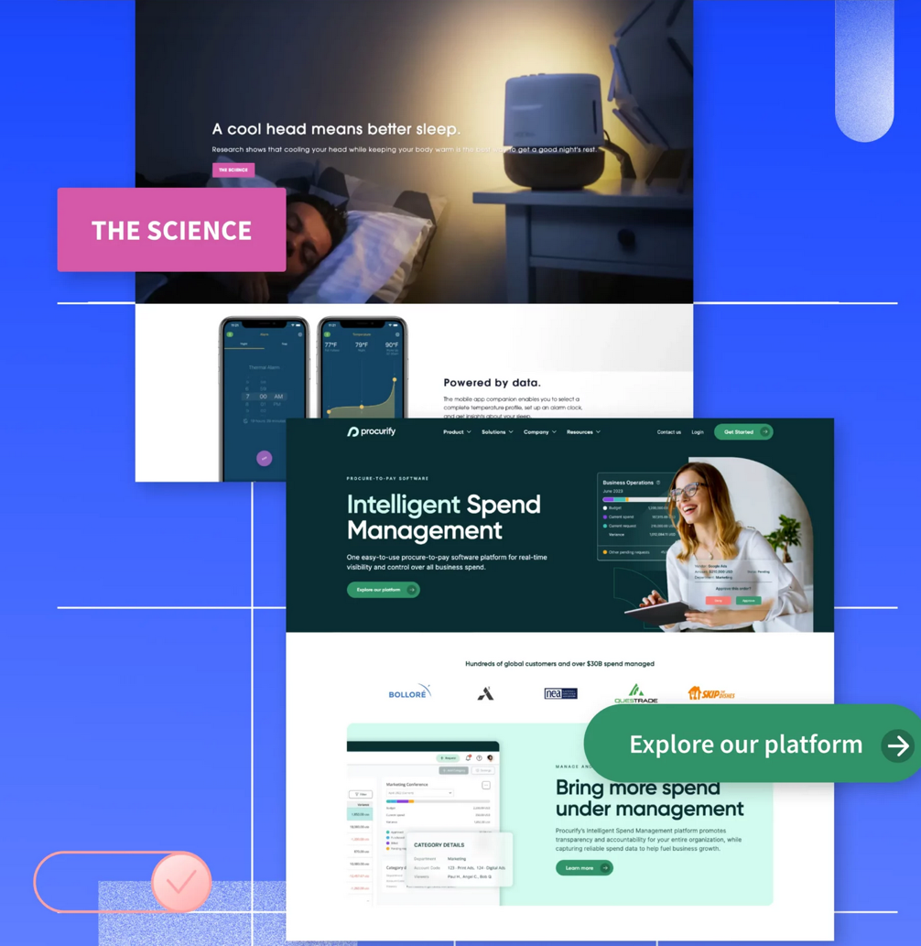
References:
Emily Bauer and Paul Parker, https://unbounce.com/conversion-rate-optimization/call-to-action-examples/ Screenshot of Call-to-action 2/3/26
#38 MailChimp Image of example used https://unbounce.com/landing-page-examples/best-landing-page-examples/ Screenshot of Landing pages example 2/3/26

Topic 41: People Habituate to Information Pg.100
Topic 37: People Screen Out Information That Doesn’t Fit Their Beliefs Pg. 91-92

